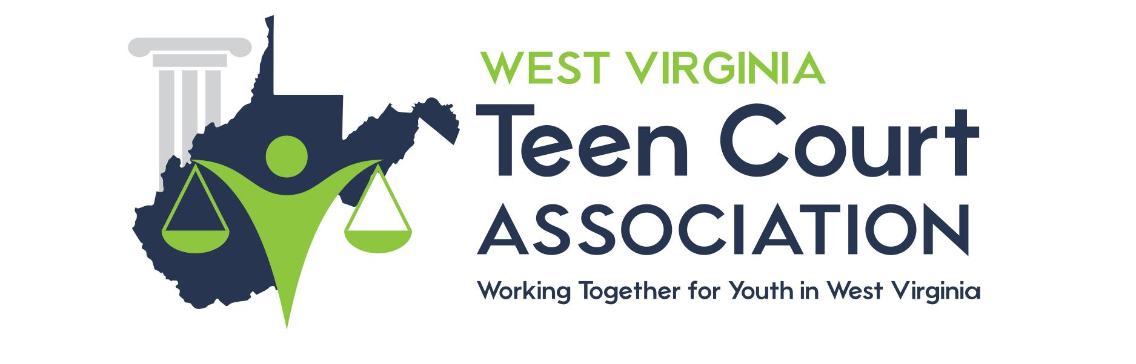

PREPARING YOUR CASE

Tips from the National Youth Court Center
Check out this website to help you prepare for your case:

http://www.youthcourt.net

________________________________________________________________________
Diversion and Prevention through Accountability and Education
Form 32B

WV Teen Court
Association
215 SOUTH WALKER STREET
PRINCETON, WV 24740
PHONE (304) 913-4956 FAX (304) 913-4964

PREPARING YOUR CASE

Tips from the National Youth Court Center
Check out this website to help you prepare for your case:

http://www.youthcourt.net

