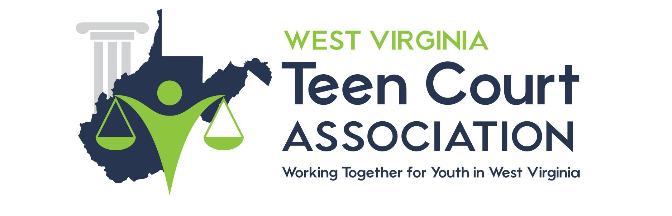

Dear West Virginia Attorney,

I am writing to you on behalf of the WV Teen Court Association. We are in need of mentoring attorneys to volunteer in our courtroom to support our student volunteers and would love for you to assist us.

Teen Court is a unique “second chance” justice program for youth between the ages of 11 and 18 who are alleged to have committed a status offense or an act of delinquency which would be a misdemeanor if committed by an adult. Upon successful completion of the program charges against the defendant are dismissed. In addition to the obvious benefit of interrupting a developing pattern of inappropriate behavior, the Teen Court program helps to reinforce self-esteem, provide motivation for self-improvement and promote a healthy attitude toward authority. Teen Court is also designed to educate youth about the judicial process. Through direct participation, Teen Court addresses responsibility for one's behavior and accountability to one's community and peers, and enhances respect for the judicial process. Each participant in Teen Court, whether a defendant, juror, bailiff, teen attorney, or adult volunteer, is involved in a positive and meaningful way.
The court configuration consists of an adult judge and mentoring attorneys with teens volunteering for the roles of attorneys, bailiff, clerk and jury members (a jury consists of both volunteers and past defendants).

Mentor attorney duties include reviewing the police report of each defendant, discussing the case with teen attorneys and attending court the night of the trial to assist the student attorney with the presentation of the case. Mentor attorneys have the option to assist with the prosecution or defense and to attend court as often as they wish (even if it’s only once a year, your assistance will make a huge difference). Our office will provide the materials and information you will need before the court date.

The success of WV Teen Court is due to the caring legal community and their time offered to the young people involved. If you are interested in becoming a mentor attorney, please complete the enclosed questionnaire and return it to us by mail or fax.

If you have any questions, please feel free to call our office at (304) 913-4956

Sincerely,

Teen Court Coordinator

