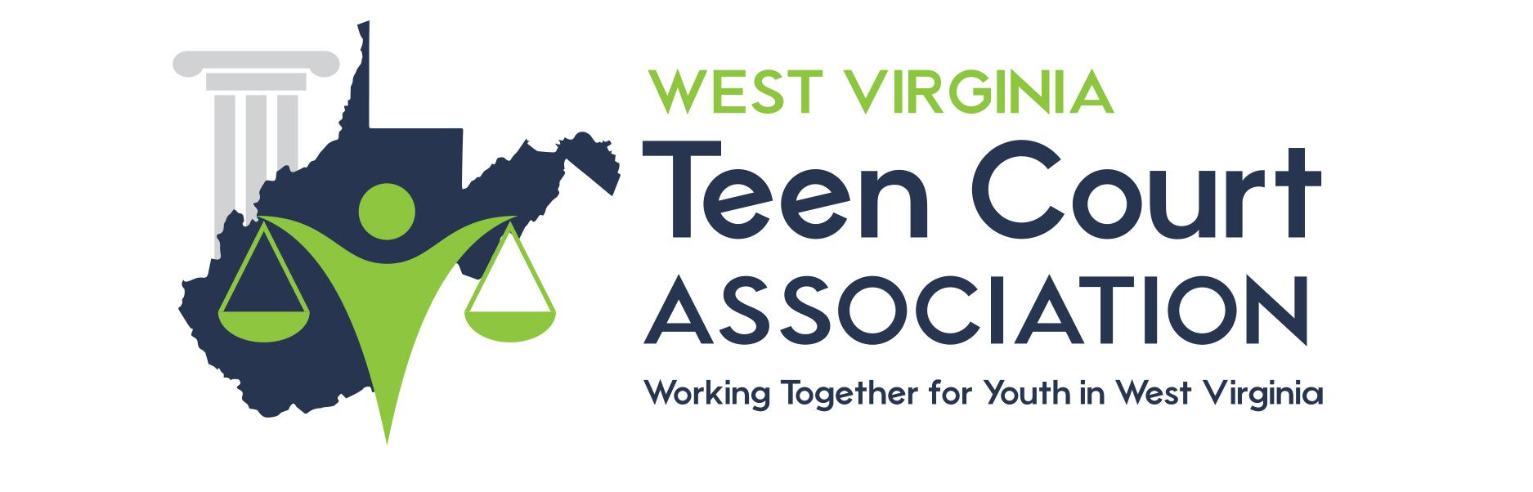

MENTOR PROSECUTION ATTORNEY PACKET

Trial Date __________________________

Location:

Time: ________ SHARP
Court begins at ________. Teen Court Coordinator and teen attorneys will arrive at ________.

Case # _________________ Teen Attorney _______________________

Phone ______________________________

Case # _________________ Teen Attorney _______________________

Phone ______________________________

Case # _________________ Teen Attorney _______________________

Phone ______________________________

Peer Court Phone: (304) 913-4956

