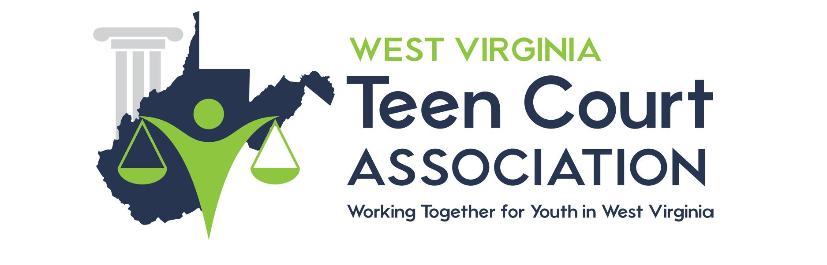

TEEN COURT PARTICIPANT SURVEY

Please help us improve the Teen Court program by answering some questions regarding the services you have received. The Teen Court staff is interested in your honest opinions, whether positive or negative. We ask you to complete this questionnaire anonymously. Please answer all of the following questions to the best of your abilities. If you have any questions about specific dates and times, please ask the Teen Court staff member conducting the exit interview. Thank you for your cooperation.

1: When did you attend Teen Court?

Month: ___________________ Year: ___________________

2: How old are you?

Age: ___________________

3: Overall, how would you rate the quality of Teen Court?

Circle: Excellent Good Fair Poor

4: Overall, how would you rate the usefulness of Teen Court?

Circle: Excellent Good Fair Poor

5: If a friend were in need of similar help, would you recommend Teen Court to them?

Circle: YES NO

6: Has your school attendance improved since your participation in Teen Court?

Circle: YES NO

7: How would you rate your satisfaction with the information you received?

Circle: Excellent Good Fair Poor

8: Do you feel your Teen Court sentence was appropriate for your offense?

Circle: YES NO, explain: _______________________________
____________________________________
____________________________________
____________________________________

9: What did you like best about Teen Court?

________________________________________________________________________________________________________________________________________________________________________________________________________________________________________________________________________________________________

10: What did you like the least about Teen Court?

________________________________________________________________________________________________________________________________________________________________________________________________________________________________________________________________________________________________

11: How would you change or improve Teen Court?

________________________________________________________________________________________________________________________________________________________________________________________________________________________________________________________________________________________________

Thank you again for taking the time to fill out this survey. Your input is extremely valuable when assessing the Teen Court program. If you or your family have any questions or concerns about Teen Court or other services that are available to you, please feel free to call the WV Teen Court office at (304) 913-4956. Staff will be more than happy to assist you.

