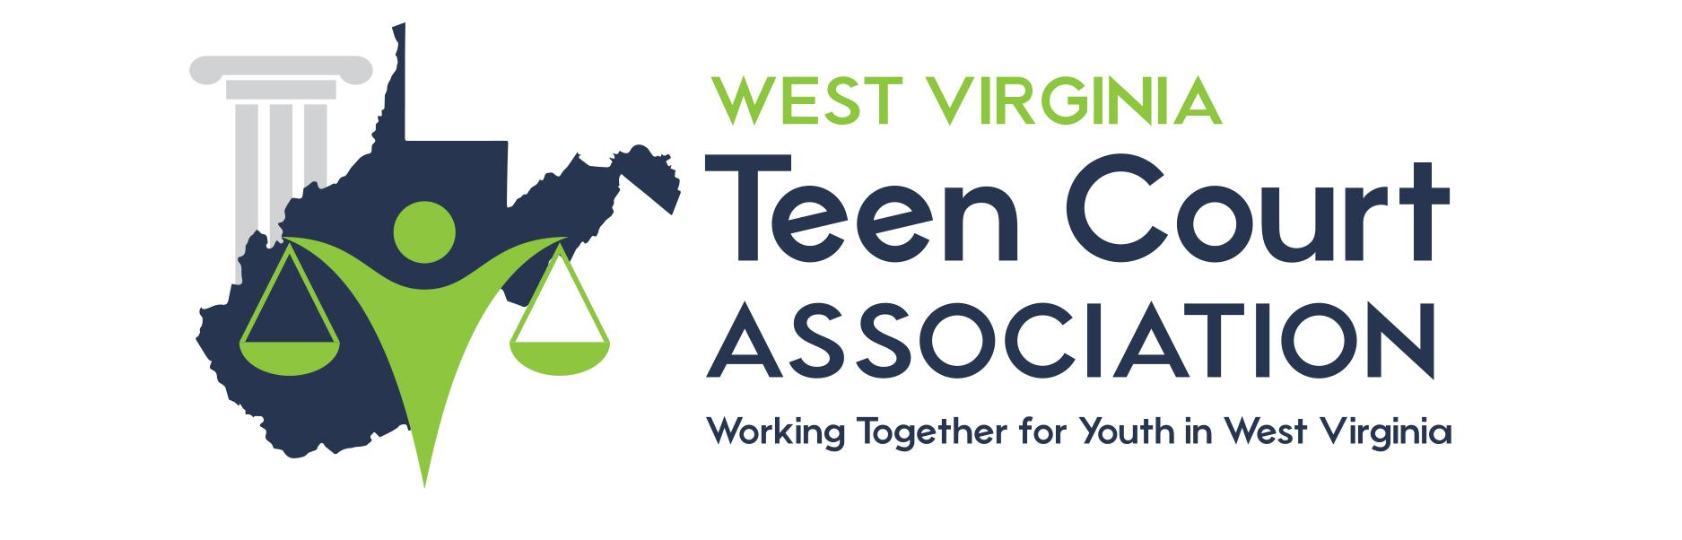

TEEN COURT PARENT SURVEY

Please help us improve the Teen Court program by answering some questions regarding the services you and your child have received. The Teen Court staff is interested in your honest opinions, whether positive or negative. We ask you to complete this questionnaire anonymously. Please answer all of the following questions to the best of your abilities. If you have any questions about specific dates and times, please ask the Teen Court staff member conducting the exit interview. Thank you for your cooperation.

1: When did your son/daughter attend Teen Court?

Month: ___________________ Year: ___________________

2: How old was your son/daughter when he/she attended Teen Court?

Age: ___________________

3: Did you attend the Teen Court session in which your son/daughter’s case was heard?

Circle: YES NO

4: Describe the changes in your son/daughter’s attitude after participating in Teen Court.

Circle: Great Improvement Slight Improvement No Change Worse

5: Describe your son/daughter’s attitude towards your family since their participation.

Circle: Great Improvement Slight Improvement No Change Worse

6: Do you feel your son/daughter’s involvement in Teen Court was an appropriate sentence for their first offense?

Circle: YES NO, explain: _______________________________
____________________________________
____________________________________

7: How much time elapsed between the offense and the court date?

Months: ___________________

8: Was the Teen Court sentence given soon enough after the offense to make a strong impact on your son/daughter?

Circle: YES NO, explain: _______________________________
____________________________________
____________________________________

9: Overall, how would you rate the quality of Teen Court?

Circle: Excellent Good Fair Poor

10: Overall, how would you rate the usefulness of Teen Court?

Circle: Excellent Good Fair Poor

11: If a friend were in need of similar help with their teen, would you recommend the Teen Court program?

Circle: YES NO

12: Do you think Teen Court should continue?

Circle: YES NO

13: How would you change or improve Teen Court?

________________________________________________________________________________________________________________________________________________________________________________________________________________________

Thank you again for taking the time to fill out this survey. Your input is extremely valuable when assessing the Teen Court program. If you or your family have any questions or concerns about Teen Court or other services that are available to you, please feel free to call the WV Teen Court Association office at (304) 913-4956.

